**DEPARTMENT OF INFORMATION TECHNOLOGY**

**INSTITUTE OF ENGINEERING AND TECHNOLOGY , INDORE**

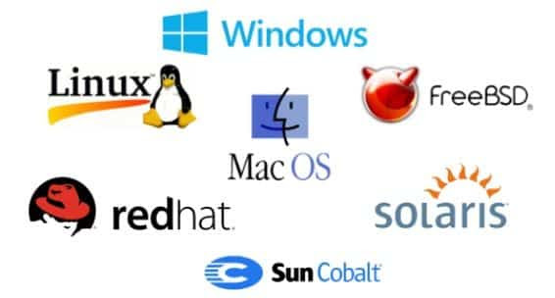

LAB ASSIGNMENT OF OPERATING SYSTEM

SUBJECT CODE: 4ITRC2

LAB ASSIGNMENT - 01

NAME : ARUSH DIXIT

ROLLNO : 23I4118

CLASS : BE 2ND YEAR IT-B

**Introduction to Linux and Ubuntu**

Linux is an open-source, Unix-like operating system kernel that serves as the foundation for various operating systems, known as Linux distributions. It was created by **Linus Torvalds** in 1991 and is widely used for servers, desktops, and embedded systems.

**Ubuntu** is one of the most popular Linux distributions, developed by **Canonical Ltd.** It is based on **Debian** and is designed to be user-friendly, secure, and stable. Ubuntu is widely used for personal computing, development, and cloud computing.

**Versions and History of Ubuntu**

Ubuntu follows a **biannual release cycle**, with a new version released every **April and October**. Each version has a **version number (YY.MM)** and a **code name** (e.g., *Ubuntu 24.10 "Jammy Jellyfish"*). Some key milestones in Ubuntu’s history include:

* **2004:** First release, Ubuntu 4.10 *"Warty Warthog"*.
* **2011:** Unity desktop introduced in Ubuntu 11.04.
* **2017:** Switched to GNOME desktop in Ubuntu 17.10.
* **2020-Present:** Improved support for cloud, IoT, and AI applications.

**Features of Ubuntu**

* **Open-Source & Free** – Available for free, with access to source code.
* **User-Friendly** – Simple interface with GNOME desktop environment.
* **Security & Stability** – Less prone to viruses, with built-in firewall and security updates.
* **Customizability** – Allows modification of UI and system behavior.
* **Regular Updates** – New versions released every 6 months, with Long-Term Support (LTS) versions available for 5 years.
* **Lightweight & Efficient** – Uses fewer system resources than Windows.
* **Software Availability** – Includes LibreOffice, Firefox, and supports Snap & APT packages.
* **Great for Development** – Supports programming languages like Python, C++, and Java.

**Difference Between Ubuntu and Windows OS**

| **Feature** | **Ubuntu** | **Windows** |
| --- | --- | --- |
| **Cost** | Free & Open Source | Paid (Proprietary License) |
| **User Interface** | GNOME (default) but customizable | Standardized UI with less customization |
| **Security** | More secure, minimal viruses | Requires antivirus protection |
| **Software Support** | Uses .deb, Snap, and Flatpak | Uses .exe and .msi |
| **Gaming Support** | Limited native support, uses Wine/Proton | Wide game compatibility |
| **System Requirements** | Lightweight, runs on old hardware | Higher hardware requirements |
| **Customization** | Highly customizable | Limited customization |
| **Updates** | Regular updates, free LTS versions | Windows Updates (can be forced) |
| **Compatibility** | Best for development, cloud, and servers | Best for mainstream applications & gaming |